**Adhoc Instructions**

* In python, we have read_json() function which read json file and return dataframe.

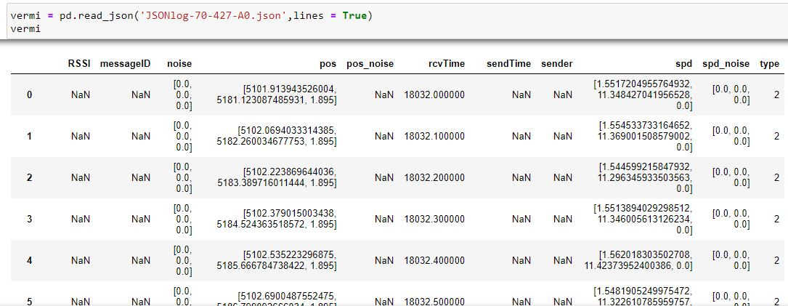

* Then we can save this dataframe as csv file by using to_csv()



* I classified data with the help of ground truth file. If we look into ground truth file there is attackerType column, which has values 0 and 1.
  + - * 0 indicates Legitimate message
      * 1 indicates Attacker

